**Lesson 6 Lesson-End Project**

**Transform the Supply Chain**

|  |
| --- |
| **Project agenda:** To transform the seafood supply chain using Hyperledger Sawtooth  **Description:** The traditional seafood supply chain industry has illegal, unreported, and unregulated fishing practices. You are required to bring traceability and accountability to the supply chain through the power of Hyperledger Sawtooth technology.  **Tools required:** Ubuntu, Web browser, Hyperledger Sawtooth  **Prerequisites:** None  **Expected deliverables:** To create a supply chain for seafood items like fish so that it can be added to the Sawtooth network and track the supply chain |

**Steps to be followed:**

1. Installing MetaMask and Creating a Wallet

**Step 1: Installing MetaMask and Creating a Wallet**

1.1 Visit <https://demo.bitwise.io/fish/>

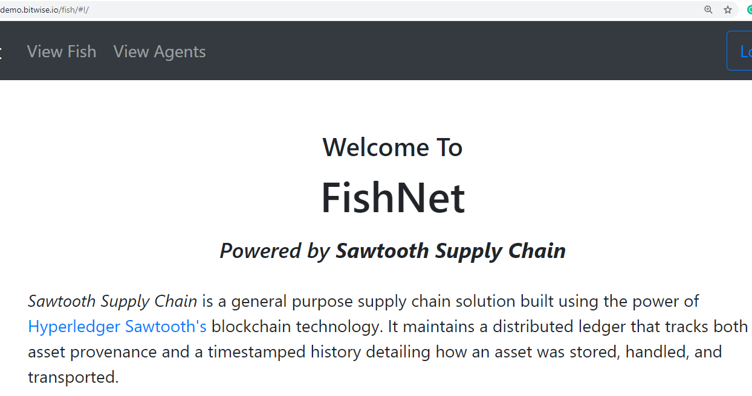

1.2 Click on the **Signup** button to create an agent

1.3 On the next screen, click on **Create a New Agent** link

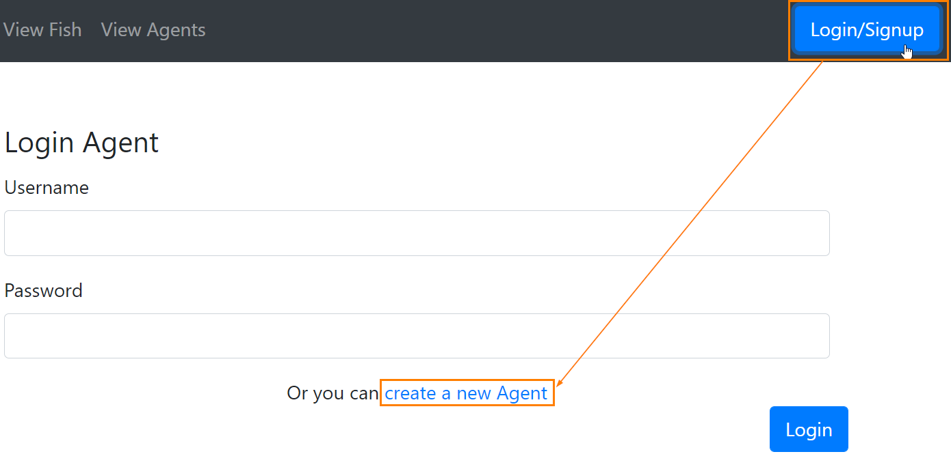

1.4 Enter the details such as **Name, Email, Username,** and **Password** then click on the **Create Agent** button

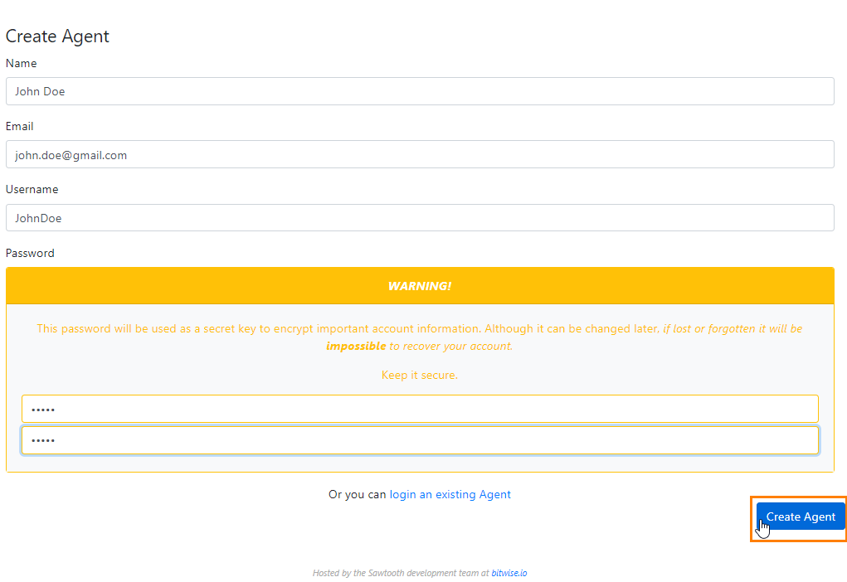

1.5 Click **Add Fish** to track a fish

1.6 Enter the fish details such as **Serial Number, Species, Length,** and **Weight**,and click on the **Create Record** button

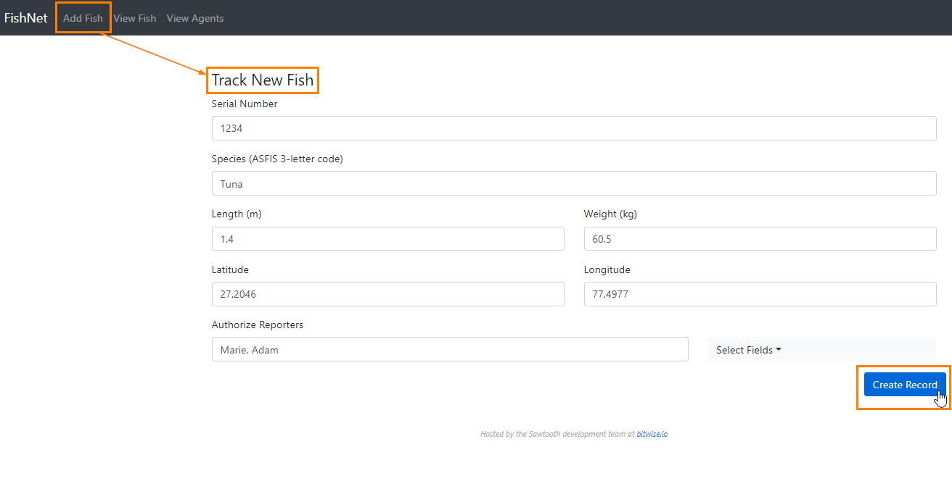

­­ 1.7 On the next screen, confirm the details and click on the **Finalize** button

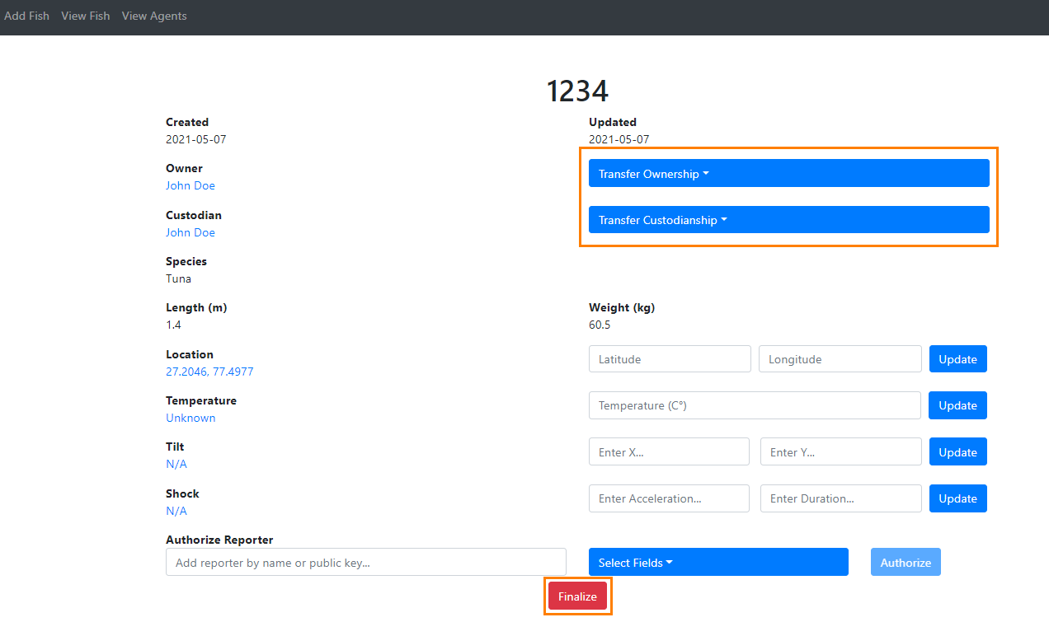

|  |
| --- |
| **Note:** You can change **Ownership** and **Custodianship** as well from the dropdown options as shown in the above screenshot. |

1.8 Once the fish is added to the network, you can see and track it from the **View Fish** option.

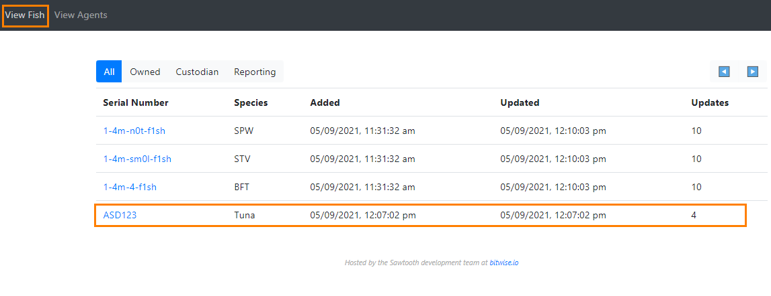

You can click on the **Serial Number** of the newly added fish to check the details.